Project 3 – Agile Story Points (time estimate)

The first picture, we created buckets with assignments from previous classes as well as tasks from Project 2. We calculated 2 hours per story point (as shown in the picture below).

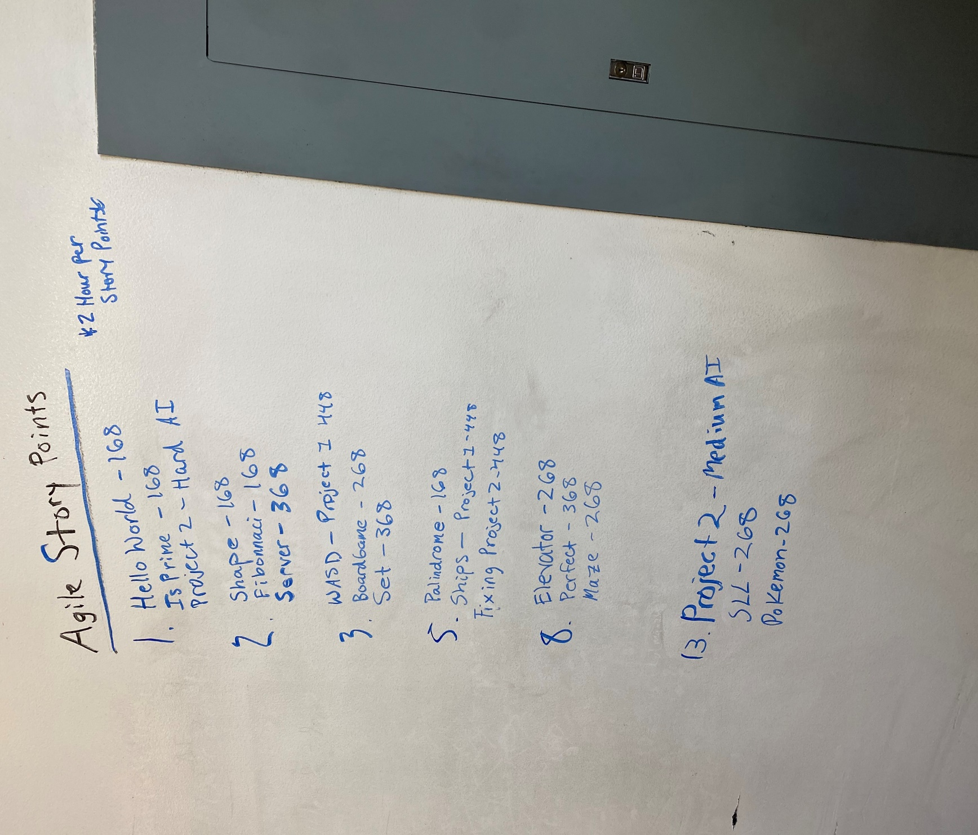

The second picture is the story point method for Project 3 and how long each task will take (shown in the picture below). We converted story points to hours by estimating how much time we spent on previous classes and Project 2. For example below, we said Force selection would take 4 hours meaning 4 hours per task for that bucket. We then calculated, 2 tasks for bucket 2 to be 8 hours (4 \*2 tasks in bucket 2 = 8 hours) and so on. The total number of hours for Project 3 was estimated to be 54 hours.

